Nancy Brashers
Statistics 7170
July 1, 2013
The first example is in Chapter 3 and deals with mean, median, mode, and midrange for given sample data. These tools are used to analyze data in discussing different measures of center. Also, you should decide if the data given is helpful in determining if it represents the total population.
Listed below are the top 10 salaries (in millions of dollars) of the St. Louis Cardinals players taken from the ESPN site http://espn.go.com/mlb/team/salaries/_/name/stl/st-louis-cardinals :
1 | Matt Holliday | 16.3
2 | Yadier Molina | 14.2
3 | Carlos Beltran | 13.0
4 | Adam Wainwright | 12.0
5 | Jake Westbrook | 8.8
6 | Edward Mujica | 3.2
7 | David Freese | 3.2
8 | Ty Wigginton | 2.5
9 | Allen Craig | 1.8
10 | Randy Choate | 1.5
Find the mean, median, mode and midrange for the given sample data. Does this tell anything about the salaries of all Major League baseball players? Do top 10 lists give insight into larger populations?
To find the mean, add the salaries together and divide by 10. There are ten salaries. 16.3+14.2+13.0+12.0+8.8+3.2+3.2+2.5+1.8+1.5=76.5/10 mean=$7.65 million
To find the median, arrange the values in order of increasing magnitude. Since the number of data values is even, add the two middle values and divide by two. 8.8+3.2=12/2 median=$6 million
To find the mode, find the value that occurs with the greatest frequency. The mode is $3.2 million because that value occurs twice in the data set and all other values only occur once.
To find midrange, add the maximum data value to the minimum data value and divide by 2. 16.3+1.5=17.8/2 midrange= $8.9 million
This is just the highest top ten salaries on one team so it is not representative of all players in general. Top ten lists do not give insight to larger populations.
In Chapter 2, visual tools called histograms are introduced and we are asked to find the sample size, class widths, class limits, and variation in order to analyze the shape of the distribution.

The histogram is taken from www.analyzemath.com .

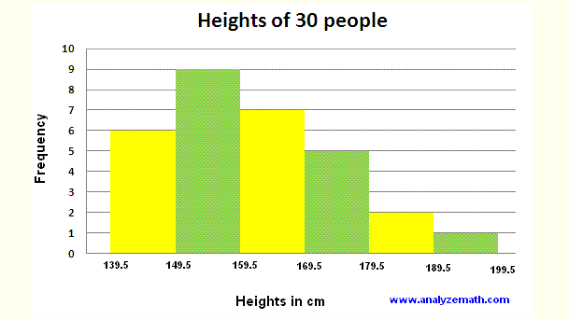
How many people are included in this histogram? What is the class width? What are the lower and upper class limits of the first class? What are the minimum and maximum heights of the people in this histogram? Do the heights appear to be reported or actually measured?
To find the amount of people in the histogram, add up the frequency of each bar. 6+9+7+5+2+1=
30 people.
To find the class width, find the difference between two consecutive lower class limits. 149.5-139.5=
10 cm
To find the lower class limit, find the smallest number that can belong to a class. In the first class it would be 139.5 cm.
To find the upper class limit, find the largest number that can belong to a class. In the first class, it would be 149.4 cm.
The minimum height would be the lowest value in the histogram, 139.5 cm. The maximum height would be the largest value, 199.5 cm.
The heights appear to be actually measured. There seems to be a normal distribution that is approximately symmetrical.
The third example is from Chapter 5. This question focuses on binomial distribution. We will find the mean variance, and standard deviation. More importantly we need to understand and interpret the values found using the maximum and minimum usual value formula.

Julie said that in a box of Fruit Loops, 33% of them are blue. A sample of 100 Fruit Loops is randomly selected. Find the mean and standard deviation for the numbers of blue Fruit Loops in the group of 100.
In a random sample 18 are blue. Is this result unusual? Does it seem that the claimed rate of 33% is wrong?

To find the mean multiply 33% and 100 to get the amount of blue Fruit Loops. 0.33x100=33 blue.
The standard deviation is found by finding the square root of npq n=the number of values in the sample which would be 100. p=the percent of Fruit Loops that are said to be blue or 0.33. q=the probability of 1-p or 1-0.33 which is 0.67. So, the standard deviation is the square root of 100x0.33x0.67 or 3.49.
To find if the result of 18 is unusual, use the maximum and minimum usual value formula. The maximum usual value is mean + (2)standard deviation or 33+ (2)3.49=39.98.
The minimum usual value is mean- (2)standard deviation or 33-2(3.49)=26.02.
18 is unusual because it does not fall in between the minimum and maximum value. It appears that the claimed rate of 33% is wrong.

