NETS 5b
The first artifact has two activities that I have done in my classroom to help with decision making and character in the classroom. Community building is important in the classroom and it helps establish expectations and reinforce the importance of collaboration and working together as a team. The second artifact is not only a way to instruct others on the technology of using Animoto, but the process of designing the learning taught me how to use that design for other technology tools. Being able to instruct others will help me to be a lead others in their learning of new technology.

Artifact 1
A community building activity that I did this year in my classroom was using the book, The Pirates Next Door by Jonny Duddle. Our school mascot is a pirate, so this book fit right in. But what I really liked about it was that it talked about a pirate going to school for the first time and not fitting in, but the little girl, Tilda, accepted him and actually liked him.
I read the book to the class and then I had them pair up and share what it was like to be a new student. Each pair also came up with ways they could lend a helping hand to other students that might be having trouble fitting in.
Then to tie up the activity, we all pledged to lend helping hands and I had them make a banner like one that I found on Pinterest http://www.pinterest.com/pin/169799848424148255/ . I am attaching a photo of the one we made.
One modification I might make is to have them help each other when making the hands for the banner and work in pairs to share ideas. This activity was very successful in that the students really linked the book to their lives, and it helped them to think about what it would be like to be a new student or in a class with new people. I think it was very effective because the banner is a constant reminder of our pledge to be good friends to one another and the students take that pledge seriously.

Another activity that I have the students do for team building is done in the winter. The children are split into groups of 4 or 5. Each group is given clues to find materials around the room or in hallway to make a snowman. Materials include hats, scarves, mittens, toilet paper and construction paper (orange and black to make eyes, nose, and three buttons). Students must work together to find materials. Then they must choose a person in their group to become a “snowman”. They then need to work together to wrap the person in toilet paper and then build their snowman with the materials given. Each group then will use the Ipad to take a picture of the finished snowman to share with the other groups.
As an extension, the class could vote on the most creative, or you put a time limit on the activity. Also you could have students write a group story to share about their snowman.
In the past, I made it a race. That was a bit chaotic and now I have chosen not to repeat that. It is a fun activity that the children love, and it helps them learn to work together to find clues and designate a specific person to be the snowman and take the picture.

Artifact 2
Using Animoto in the Classroom
Instructional System Design
Cami Hackmann, Stephanie Butler, Kendra Heier, Shannon Culver, Nancy Brashers
May 2014

Group Responsibilities
Name | Role | Contributions
Cami Hackmann | Project Manager | Broad Goals and Big Ideas, Learning Objectives, Formative Evaluation, Summative Evaluation, Appendices, Materials
Stephanie Butler | Team Member | Broad Goals and Big Ideas, Procedural Analysis, Table of Contents, Learning Objectives, Appendices, Materials
Kendra Heier | Team Member | Broad Goals and Big Ideas, Learning Objectives, Needs Assessment, Contextual Analysis, Appendices, Materials
Shannon Culver | Team Member | Broad Goals and Big Ideas, Learning Objectives, Needs Assessment, Learning Experiences/Instruction, Appendices, Materials
Nancy Brashers | Team Member | Broad Goals and Big Ideas, Learning Objectives, Procedural Analysis, Implementation Plan, Appendices, Materials

This project is designed to deliver instruction to educators on how to use Animoto in their classroom to enhance instruction. We will show educators how to use Animoto on an iPad or PC. Instruction will be delivered via a workshop. In addition, there will be handouts available for educators to take home. Course content will cover obtaining an educator account and creating engaging videos to enhance instruction.

Table of Contents

SECTION 1: DESIRED RESULTS…………………………….……………………………………..3-8

A. Broad Goals and Big Ideas…………………………………………….…………………………….3

B. Learning Objectives………………………………………………………..……………...………..3-4

C. Needs Assessment……………………………………………………...……..…………………..4-8

D. Task Analysis…...………………………………………………………………..……………………8

SECTION 2: EVIDENCE OF ACCEPTABLE RESULTS……………………...………………….8-10

A. Formative Evaluation…………………………………………………………….…………………...9

B. Summative Evaluation…………………………………………………………………………….9-10

SECTION 3: LEARNING EXPERIENCES AND INSTRUCTION………….……………………….10

A. Learner Analysis...…………………….…………………………………..…….……………….10-11

B. Contextual Analysis…...…………………………………………………..……………………..11-13

C. Types of Learning Experiences and/or Instruction……...…………………………………...13-14

D. Materials for Training program or Learning System…………...………………………………...14

E. Implementation Plan, Including Schedule…...………………………………………………..14-15

SECTION 4: REFERENCES……………………………………………………………..…………....16

SECTION 5: APPENDICES..…………………………………………………………..……..……17-42

A. Needs Assessment Instruments and Evaluation Materials………………………………….17-32

B. Materials, Schedules, Outlines, etc……………………………………………...……….....…32-42

1. Desired Results
I.A. Broad Goals and Big Ideas
Teachers today have the responsibility to educate and model the appropriate use of technology in the classroom, along with teaching various standards to their students. By using Animoto in the classroom, teachers will be able to encourage 21st century learning habits through the use of multimedia presentations. Animoto is important because it is valuable tool that allows teachers to quickly and effectively engage students in various lessons. Our training will focus on the basic skills needed to create an Animoto including the use of a video camera, adding pictures, video, text, audio, and organizing video with an iPad or PC. Our goal is to provide a two part face-to-face training addressing the skills needed to film, edit, and share Animoto videos. The first part will focus on using an iPad and the second part will focus on using a PC. Our target audience will focus on teachers that have basic computer skills and no prior experience with Animoto.

Goal 1: Educators will be able to create videos that will enhance course material.
Goal 2: Educators will be able to import pictures and audio in Animoto.
Goal 3: Educators will be able to operate a camera to film content for their presentations.
Goal 4: Educators will be able to remove videos from their devices and import them into their presentations.
Goal 5: Educators will be able to create an educator account in Animoto.
I.B. Learning Objectives
Goal 1: Educators will be able to create videos that will enhance course material.
1.1 Following the workshop, educators will be able to create videos in Animoto by using the create video feature successfully.
Goal 2: Educators will be able to import pictures and audio in Animoto.
2.1 Following the workshop, educators will be able to import pictures in Animoto by using the upload picture feature successfully.
2.2 Following the workshop, educators will be able to import audio in Animoto by using the upload audio feature.
Goal 3: Educators will be able to operate a camera to film content for their presentations.
3.1 Following the workshop, educators will be able to operate a camera by recording a video and uploading it on a computer.
3.2 Following the workshop, educators will be able to upload a video onto the computer with 100% accuracy.
Goal 4: Educators will be able to remove videos from their devices and import them into their presentations.
4.1 Following the workshop, educators will be able to remove videos from their device and import them into Animoto with 100% accuracy.
Goal 5: Educators will be able to create an educator account in Animoto.
5.1 Following the workshop, educators will be able to create an educator account in Animoto with 100% accuracy.
I.C. Needs Assessment

Planning

Target Audience
This training will target elementary and secondary school teachers. It will be presented in two parts. Part one will address using Animoto with a PC and Part two will address using Animoto with an iPad.

Strategy
This needs assessment will be conducted using Rossetts framework. This assessment will gather information to help design a workshop that will be beneficial and meet the needs of our target audience.

Participants
Educators with little to no experience using Animoto as a teaching tool.

Data Collection
Qualitative research methods were chosen to gather data. Survey and questionnaire methods of data collection will be used. The survey will be distributed to all educators. A survey will allow us to gather data from a large number of educators. This will also allow educators to complete the survey at their own convenience. A reminder will be sent one week following the initial survey to remind educators to complete the survey. The interviews will be conducted with a smaller number of educators that meet the criteria.

Scheduling
The survey and interview will be piloted with a small number of educators so that revisions can be made before they are used with the target audiences. Online surveys will be sent via Survey Monkey and will be anonymous and on a volunteer basis. Interviews will be scheduled with educators and administrators via e-mail. They can be conducted by phone, Skype, or face to face.

Tools
We decided to use surveys and interviews to collect data. The teachers were given a survey that contained a combination of questions from actuals, feelings, and causes in the needs assessment. A draft survey was created, piloted, and revised. It was then sent to the target audience. Interviews were also conducted. Interviewees were all asked the same questions to maintain the validity of the study.

Data Analysis
The data will be collected and analyzed. This will help determine what teachers are looking for in a workshop about Animoto. It will also determine skill levels, resources available, and feeling toward Animoto and using videos for instruction. Survey questions were both multiple choice and open ended. Answers to the interview questions will be carefully examined to determine how to best design an Animoto workshop for educators. More than one data collection instrument was used in order to maintain the validity of the study.

See Appendix A.1.1 for Survey of Target Audience Survey questions and interview questions.

Below is the Table for Needs Assessment
Types of Information | What do you need to know? | Why do you need to know this? | Information Sources | Types of Procedures (Instruments)
Optimals
1 | What is Animoto? | This will ensure that teachers understand what Animoto is, it’s purpose, and benefits. | Online tutorial programs  animoto.com | Informal interview and survey of experienced users new and experience Animoto users
2 | What technical skills will teachers need in order to use Animoto? | This will determine if extra training is needed. | Online tutorial programs  animoto.com  experienced users | Informal interview and survey of new and experience Animoto users
3 | How can Animoto be used in the classroom? | This will help determine topics needed for training. | Teachers | Informal interview and survey of new and experience Animoto users
4 | How can Animoto be used in different learning environments? | This will help determine topics needed for training | Teachers | Informal interview and survey of new and experience Animoto users
5 | What other skills will teachers need in order to use Animoto? | This will determine if extra training is needed. | experienced users | Informal interview and survey of experience Animoto users
6 | What equipment should teachers have in order to use Animoto? | To determine if limited access to equipment is a concern | experienced users | Informal interview and survey of experienced Animoto users
7 | What are the advantages and disadvantages of using Animoto in the classroom? | This will determine the focus of the training. | Teachers  experienced users | Informal interview and survey of experienced Animoto users
Actuals | What do teachers want to learn about Animoto?  What prior training do teachers have with creating video for instruction?  What do teachers know about filming video?  What do teachers know about editing video?  What do teachers know about uploading video with Animoto?  What is the most difficult aspect of creating video with Animoto?  What are the advantages to using Animoto? | To determine where to focus for the training.  To determine the skill level of teachers.  To determine what technology will be used to film.  To determine what technology will be used to edit.  To determine what technology will be used to upload.  To determine the problems teachers might have.  To determine if using Animoto will generate student engagement. | Teachers  experienced users | Informal interview and survey of new and experience Animoto users
Determining Causes | What could cause teachers to be unable to use Animoto effectively?  Are there specific aspects of Animoto that could cause problems?  What is the teacher expertise on creating Animoto video?  Are there issues with any of Animoto’s features?  Do all teachers have a connection to the internet to upload?  Do teachers have all necessary equipment needed for filming and creating video in Animoto? | To determine if teachers have any difficulties.  This will determine the causes of problems that are experienced by teachers when using Animoto  To determine teachers’ background and prior knowledge.  To determine if teachers understand how to fully use Animoto’s features.  To determine if Animoto is available to all teachers.  To determine if all teachers have resources that are needed. | Teachers | Informal interview and survey of new and experience Animoto users
Feelings | Do you feel Animoto will be useful and effective in the classroom?  Do you feel it is simple or complicated to use?  How do students feel about learning through video?  Can teachers improve students’ engagement through video?  How do you feel about using video to teach?  How secure are you with teaching through video? | This will determine whether teachers feel Animoto is beneficial for the classroom.  To determine teachers’ concerns.  To determine student interest.  To encourage communication of effective ways to teach with Animoto.  This will determine teachers’ attitude toward teaching with Animoto  This will determine if teachers have any uncertainty. | Teachers | Informal interview and survey of new and experience Animoto users
Possible Solutions | What is the most effective way to train teachers to use Animoto? | This will help trainers determine if a two part training will be the most efficient way to train teachers to use Animoto. | Animoto  Experienced users or specialist | Survey new and experienced users of Animoto

I.D. Task Analysis

A Procedural Analysis was completed for the PC and IPad to meet the five learning objective goals that were set for the project. Steps were clearly stated in the analysis that outlined the processes of creating videos in Animoto, importing pictures and audio, operating a camera to film content for the presentations, removing videos from devices and importing them into the presentations, and creating an educator account in Animoto. They are in performance terms and clearly state the step by step procedures that need to be followed in order for the goals to be met. The analysis was also used to help create handouts for the workshop. The Procedural Analysis can be found in Appendix A.2.

II. Evidence of Acceptable Results
II.A. Formative Evaluation
A formative evaluation will be given to experienced teachers using Animoto. It will be conducted to determine the overall efficiency of our presentation and needs of our audience. Changes will be made to the presentation based on the data collected. The overarching question is whether users are able to use Animoto to create a short video effectively and independently.

Key Questions

- How often do you use Animoto?
- How familiar are you with using Animoto?
- What is the most challenging part of using Animoto?
- What is an example of a way you use Animoto in the classroom?
- What is the most beneficial aspect of Animoto?
- What are some technology skills required to use Animoto?
- How much time did it take to complete a presentation? Is it reasonable?
- What method is best for teaching educators to use Animoto?

Approaches to Gain Information
Approach 1: Survey of Experienced Classroom Teachers using Animoto
To gain an understanding of how Animoto is used in the classroom and teachers’ needs when using Animoto, a survey will be given to experienced classroom teachers. This data will be given prior to the presentation to distinguish beneficial information that educators may need.

Approach 2: Interview of Experienced Technology Presenters
An interview will be conduct with three presenters who are familiar with presenting new technology software to teachers. Each interviewee will be given all materials prior to the interview to read over. They will be asked a series of questions to determine if our schedule, materials, and hands on training will be user friendly for our target audience.

II.B. Summative Evaluation (including Assessment of Learning)
The summative evaluation will be given to determine the effectiveness of the overall presentation. Through the assessments, we will use this data to review how teachers are using Animoto in their classrooms, what was effective in our presentation, and what needs to be changed prior to our next presentation.

Key Questions

- Are audience members able to create an Animoto account?
- Are audience members able to login to Animoto?
- Are audience members capable of creating a video with a camera or video camera?
- Are audience members able to import videos and/or images?
- Do audience members choose a theme for their presentation?
- Is importing video and/or images complete effectively?
- What were the audience members’ reactions to the presentation?
- Are audience members able to use Animoto effectively?

Approaches to Gain Information
Approach 1: Survey of Audience Members
A survey will be sent to all educators three weeks after the presentation. This survey will ask a variety of questions about the overall presentation, audience members’ current use of new information, and how beneficial the presentation was for each participant.

Approach 2: Performance Event with Focus Group
Five educators from the presentation will be given a variety of tasks to complete upon completion of the presentation. These educators may use all handouts and resources provided from the presentation in order to complete the basic tasks using Animoto. This will demonstrate the ability of our audience to use Animoto independently, and show any gaps in their learning.

III. Learning Experiences and/or Instruction
III.A. Learner Analysis
Our Animoto workshop will focus on K-12 teachers in the school district. By completing a learner analysis, we are determining the best way to meet the needs of our educators. Learner factors are categorized depending on orientating, instructional, and transfer contexts. Data will be gathered in the survey of target audience.

Orienting Context | Data Collection for Information
Learner Factors
1. What are the educators’’ demographics?  2. How will the workshop improve the educators’ instruction?  3. Do the teachers have any prior experience creating videos?  4. How many years of teaching experience do the teachers have?  5. What grade/subject do the teachers teach?  6. What are the goals of the educators? | Survey of target audience emailed to all teachers

Instructional Context- | Data Collection for Information
Learner Factors
1. Do teachers have experience creating videos?  2. Have the teachers ever been to a workshop on Animoto before?  3. Are educators comfortable using videos to teach? | Electronic survey questionnaire emailed to district employees

Transfer Context- | Data Collection for Information
Learner Factors
1. Does the teacher perceive the training as useful in the classroom?  2. Do teachers understand the support available after training? | Electronic survey questionnaire emailed to course participants

Assumption of Educators Experience
The following assumptions have been made in the learner analysis. Educators are expected to be classroom teachers with varying levels of teaching experience representing grades K-12 and subject areas. The educators do not have experience with Animoto, but do have basic computer skills such as:
- Operating a keyboard and mouse
- Accessing files
- Word processing

III.B. Contextual Analysis
Contextual analysis was developed for the educators that will be attending the Animoto workshops and divided among the orientating, instructional, and transfer contexts. Data will be gathered in the following ways:

Data Collection #1: Survey of Target Audience in Survey Monkey
Data Collection #2: Survey of Experienced Users
Data Collection #3: Interview of Experienced Technology Presenters
Data Collection #4: Survey of Audience Members
Data Collection #5: Performance Events with Focus Group
Data Collection #6: Interview District Technology Director and Administrator Prior to Presentation
Orienting Context | Data Collection for Information
Immediate Environment Factors
1. Do teachers have access to a computer or device with Internet access? Home? Library? School? Smart Phone? | Electronic survey questionnaire emailed to district employees  Face-to-face interview with district technology director
Organizational Factors
1. Will the teachers be provided release time for the training?  2. Will release time be provided to practice using the technology and plan for use in the classroom?  3. Are there any incentives being offered to teachers for attending the training?  4. What is the budget for the training? | Interview with district administration

Instructional Context- | Data Collection for Information
Immediate Environment Factors
1. Is the location of the workshop convenient for teachers?  2. What would be the best time and day for the largest number of teachers?  3. Is the room large enough for the number of educators? Are there enough chairs?  4. Will the instructors be available after the workshop to answer questions? | Electronic survey questionnaire emailed to district employees  Face-to-face interview with district technology director
Organizational Factors
1. Are there PCs or iPads available for teachers to practice using Animoto? Is there a one to one ratio?  2. Are digital cameras and video cameras available for use?  3. Are recording devices available?  4. Will there be a SMART board available in the training room?  5. Will there be a tech available to help set up and troubleshoot during the workshop? | Face-to-face interview with district technology director

Transfer Context- | Data Collection for Information
Immediate Environment Factors
1. Are there any technology needs preventing teachers from using Animoto in their classrooms?  1. How much do teachers plan on using Animoto in their classrooms? | Electronic survey questionnaire emailed to course participants
Organizational Factors
1. Does the learner refer back to the resources provided when they need help with Animoto?  2. Is there time provided for educators to collaborate and use Animoto to plan lessons?  3. Are the district techs trained in the use of Animoto and capable of providing support?  4. Are there resources educators can use to receive support and collaborate (blog, Wiki, etc.)?  5. Will there be further training to keep educators up-to-date with the changes in Animoto? | Electronic survey questionnaire emailed to course participants  Interview with district administration  Face-to-face interview with district technology director

The following assumptions have been made in the contextual analysis. We are assuming there is internet access with Wi-Fi available in the district.

III.C. Types of Learning Experiences and/or Instruction
This workshop will take place in two computer labs in the high school over the course of two sessions. Each session will last approximately three hours. Learning will involve a combination of lectures, demonstrations, and independent practice. Facilitators will also be observing during independent practice. There must be a computer and iPad, both with internet access, available for each participant. The workshop materials will be given on the first day of the training. Materials will include step by step instructions on how to create an Animoto educator account and how to create an Animoto video. In addition to the training, students will have the option to work on the training outside the workshop from the handouts given during the workshop.

Goal 1: Educators will be able to create videos that will enhance course material.
Goal 2: Educators will be able to import pictures and audio in Animoto.
Goal 3: Educators will be able to operate a camera to film content for their presentations.
Goal 4: Educators will be able to remove videos from their devices and import them into their
presentations.
Goal 5: Educators will be able to create an educator account in Animoto.

III.D. Materials for Training Program or Learning System
Sample training materials were created for the first part of the training workshop where the educators will be given step by step instructions to create an educator Animoto account. Instructions also will include how to make a basic video. Later in the training handouts on what types of files Animoto accepts dealing with audio and video will be used. Educators will be given a take away card printed on cardstock containing a QR code for quick access to the Animoto website. The card also provides a place for their username and password for the Animoto site. The handouts for training are located in Appendix B.3.

III.E. Implementation Plan for Your Product, including Schedule and Logistics
Implementation Plan
Facilities, Equipment, Materials, and Supports
The workshops will be presented in two computer labs in the high school. Requirements include space large enough for sixty educators. There must be a computer and iPad, both with internet access, available for each participant. Each lab will have a Smartboard available for use. There will also be three digital cameras and video cameras available for use for each lab. A tech will be available to help setup and troubleshoot before and during the workshop. Educators and presenters will have the opportunity to apply for Professional Development funds as an extra incentive to attend the training.
The workshop materials will be given on the first day of the training. Materials will include step by step instructions on how to create an Animoto account and how to create an Animoto video.
Logistics
1. Workshop Design and Development:
Learning Objectives for workshops created by all group members.
2. Formative Evaluation:
Formative assessments developed by all group members.
Formative assessment including surveys and interviews will be administered by all group members.
3. Stephanie Butler, Kendra Heier, and Nancy Brashers: materials for training including handouts with specific instructions for using Animoto and the features of the program.
4. Training will be delivered in the workshop. Educators will be offered professional development opportunity through announcements and emails from building principals and school technology department. Financial reimbursement will be offered through an application to the professional development committee.
5. Workshops will be presented with all team members.
6. Summative Evaluation:
Summative assessments developed by all group members.
Summative performance assessment completed by Cami Hackman and Kendra Heier.
Summative assessment surveys will be administered and collected by all group members and then evaluated so that changes to workshop can be made if necessary.
See Appendix B.2 for the Implementation Schedule

References
www.animoto.com
http://help.animoto.com/home

Appendices
Appendix A. Needs Assessment Instruments and Evaluation Materials
A.1 - Needs Assessment Instruments
A.1.1 - Survey of Target Audience in Survey Monkey
https://www.surveymonkey.com/s/DC3JPFD

1. How many years of teaching experience do you have and what grade/subject do you teach?

2. What experience do you have with video? Check those that apply.
____ Filming video
____ Editing video
____ Uploading video
3. Do you have any prior experience creating videos?
____ Yes
____ No
4. Do you have access to a computer or device with Internet access?
____ Yes
____ No
5. Do you typically use a PC or an iPad in the classroom?
____ PC
____ iPad
6. What is your computer skill level?
____ Beginner
____ Intermediate
____ Expert
7. Have you ever been to a workshop on creating Animoto videos before?
____ Yes
____ No
8. Do you feel using videos for education is an effective tool?
____ Not at all
____ Moderately effective
____ Extremely effective
9. How do you feel Animoto can be used in different learning environments?

10. What would you like to learn about Animoto?

A.1.2 - Questions for Survey and Interview
Survey of Experienced Users in Survey Monkey
1. How often do you give presentations using Animoto?
____ How often do you give presentations using Animoto? Daily
____ Weekly
____ Monthly
2. How familiar are you with Animoto?
____ How familiar are you with Animoto? Very familiar
____ Somewhat familiar
____ Not very familiar
3. What is the most challenging part of using Animoto?

4. Give an example of how you use Animoto in the classroom.

5. What is the most beneficial aspect of using Animoto?

6. What are some technology skills needed to use Animoto?

7. How much time did it take / do you think it will take to complete a presentation? Is this a reasonable amount of time?

https://www.surveymonkey.com/s/K2HQH7Y

A.2 Procedural Analysis Detailed Outline
Procedural Analysis for PC
- Turn the computer on
- Make sure your computer has internet access.
  - We will be using Google Chrome during the workshop since that is what is standard on the school district’s laptops. If your computer does not have Google Chrome, you can download it through https://www.google.com/intl/en/chrome/browser/.
  - If you have Google Chrome, continue to the next step.
- Open Microsoft Google Chrome
- Go to the Animoto website at http://animoto.com/
- Create an Animoto Educator Account
  - Create an account by clicking on “Sign up” in the top right corner of the home page
    - Complete the registration process--be sure to use your educator email and click on the drop down box that says you will be using the videos for education.
    - Once you have an account, scroll to the bottom of the home page and click on the link that says “Education.”
      - Once you are on that page, click where it says “Learn More” after where it says “Are you a teacher?”
      - Click “Apply now”
      - Fill out the Animoto for Education Application
      - After your application is submitted, a promo code will be displayed. Copy or write down this code.
    - To get your educator account, click on your name at the top right of the page and the select “Account.”
      - Where it says “Redeem promo code,” enter the promo code that you were just given and then click “submit code.”
      - When you submit the code, it will say “You are currently an Animoto for Education customer.”
- Create an Animoto Video
  - Click “Create” in the top right corner of the web page
    - Choose the style that you would like for your video. You can change this at any time if you choose to. For the workshop, we will show “Animoto Original” for the example.
      - Click “Create Video.”
        - Click “Skip” to skip the tour of creating a video in Animoto
      - To add photos, video, and text in Animoto, click the box with a plus sign in it. This will create individual screenshots in your video.
    - Add a title screen with your name by clicking on the box with the plus sign in it and clicking on the “T”
      - For the title, enter in your name and then click save.
    - To import pictures and videos from Animoto, click on the “Add pics and vids” link on the left side of the page, then select “Upload Pictures and Videos.”
      - At this point, you can upload your own pictures and videos from your computer, or you can use Animoto’s Image Library or Video Clip Library.
        - If you would like to use Animoto’s collection of pictures or videos, click on “Image Library” or “Video Clip Library” and select the picture or video you would like to include in your video.
        - If you would like to capture import your own pictures or videos, continue to the next step.
    - Capture pictures and video on your camera to use in your Animoto videos.
      - To take a picture, make sure your camera is on and the lens cap is off.
        - Point the camera at the image you would like to photograph
        - Find the photo button--top right corner of the camera
        - Hold the camera still and hold down the camera button until the picture is taken
      - To take a video, make sure your camera is on and the lens caps is off.
        - Turn your camera to the video camera setting. You can do this by turning the selection wheel on the camera to the picture of the video camera. If your camera does not have this, you will need to change it to the video mode in the menu settings.
        - Once your camera is in the video camera mode, point your camera at the images you would like to record and click on the camera button to begin recording. To stop the recording, click the camera button again.
          - Some camera have a record button. If yours does, click the record button to begin and end recording.
    - Import pictures and videos from your camera to use in Animoto videos.
      - If you have a memory card, you will first need to take it out of your camera and insert it into the computer. The “Removable Disk” dialog box will appear and you will need to click “Open folder to view files.”
        - Double click each picture or video that you would like to import into your Animoto video.
        - Once you have selected all of your videos or pictures you would like to import, click “edit” and “copy to folder.”
        - In the “copy items” dialog box, click “my documents,” “my videos,” and then “copy.”
        - All of your pictures and videos are now in “my videos” folder.
      - If you have a USB cord, you will need to attach your USB cord to your camera and the computer. After the USB cord is attached, you will follow the same steps as you would if you had a memory card.
    - Import your own pictures and videos into Animoto videos
      - Click “Add pics and vids” and then “Upload Pictures and Video”
      - Go to your “My Videos” folder and select the pictures and videos that you would like
        - You will have to import each picture and video one at a time
    - Import audio into Animoto videos
      - If you would like to change the audio that is already preset in the Animoto videos, you can do that by using the audio choices already in Animoto, or you can upload your own music to add to the videos.
        - To choose one of the music choices from Animoto, click on the title of the song that is already in your video. Then all you need to do is click on the new song that you would like.
      - To upload your own music, you will need to save an mp3 track the same way you did the pictures and then upload it into the video.
        - Once the audio is saved on the computer, you will click on the preset song title in the video. Once that dialog box appears, you will click “Upload Songs.”
        - Then, find the mp3 that you saved to the computer. This will then add that song to your video.
    - Saving/Sending videos from Animoto
      - When you are finished creating your video, you will click “Preview Video” on the left side of the screen
        - If you like the video, you can produce the video.
        - If you would like to continue to edit, you can click “or continue editing”
      - To produce the video, you will need to enter in a title for your video
        - After it is produced, you can do the following to share your video:
          - Email
          - Tweet
          - Link to a website
          - YouTube
          - Embed it into a website
          - Download it on your computer
            - To download it to your computer, click “Download” and then choose mp4. This is the only feature allowed free of charge with an Educator Account
            - After you choose that, it will then be available on your computer

Procedural Analysis for iPad
1. Turn on iPad.
2. Make sure your iPad has internet access.
3. Go to App Store.
4. Download Animoto Video Maker.
5. Open Animoto Video Maker.
6. Create an Animoto Account.
a. Create an account by choosing “Sign up with email”.
b. Enter first and last name, email address, and a password.
c. Click “Sign up”.
7. Create your Animoto Video.
a. Click on “Create video” in the upper right hand corner of the screen.
b. Choose up to 300 photos off of your device.
i. Click on the photos so the checkmark is highlighted green.
ii. After you have chosen your photos, click the blue arrow at the top of
the phone picture.
c. Select the style you would like for your video. You can change this at any
time if you choose to. For the workshop, we will show “Coming Up Roses”.
d. Select the music you would like for your video.
i. For the workshop, we will select “Smile” from the Animoto choices.
ii. You can choose to add music from your device by clicking the “add
music from your device”, but you must have license to use that music.
You must accept the submission terms.
e. Click the blue arrow at the top of the phone picture.
f. Set up the intro for the video.
i. Choose a title for your video by typing it in by the blue “T” in the intro
box.
ii. Leave or change the date for the video by typing it in by the second
blue “T” in the intro box.
g. Set up the outro for the video.
i. Click by picture in outro box. Add a caption to the picture if you would
like one.
ii. Click on the picture to change pictures. Then repeat clicking by the
new picture to add a caption. Repeat until you have added as many
captions as you wish.
h. Preview the video by clicking the blue “preview” at the top of the phone
picture.
i. Type a description in the description box by clicking on the words
“What is this about?”
ii. Save video by clicking the blue “Save video” in the right hand corner
of the phone picture during the preview phase.
i. Share video.
i. Click on the button at the bottom of the screen by “Share video”.
ii. After it is produced, you can do the following to share your video:
1. Email
2. Tweet
3. Facebook
4. Link to a website
5. YouTube
6. Embed into a website
7. Pinterest
8. WordPress
9. Tumblr
10. Blogger
11. Vimeo
12. Wistia
13. Smugmug
14. LinkedIn
iii. You can download your video for a charge.

A.3 Instruments for Formative Evaluation
Interview of Experienced Technology Presenters
Thank you for taking the time to meet with us today. We are developing an instructional course for using Animoto for Education. As an experienced presenter we value your feedback. The purpose of this interview is to determine changes in the presentation that may be necessary prior to implementation.

1. After reading through the provided materials, is the presentation broken into manageable steps?

2. Does the presentation allow enough time for each audience member to complete the specified task? For example, create an account, choose a theme, etc.

3. What would be an effective way to train educators to use Animoto?

4. How can the presenters provided support for the target audience after the presentation?

5. What part(s) of the presentation should be changed? Why?

Interview Questions for Instructional Design Expert
Thank you for meeting with us today. We are creating an instructional course for educators on how to use Animoto in their classroom to enhance instruction. We will show educators how to use Animoto on an iPad or PC. We respect your opinion regarding our course design. The objective of this interview is to decide if there are changes necessary to improve our course.

1. Is the course reasonably arranged and organized?

2. Is the time frame of the course appropriate?

3. Does the content provide educators with a clear understanding of the purpose of the course?

4. Is the level of instruction appropriate?

5. Is the subject matter and instructional methods appropriate for the goals?

6. Is there any other comments, ideas, or suggestions you have for improving our workshop?

Interview District Technology Director and Administration Prior to Presentation

Thank you for taking the time to meet with us today. We are developing an instructional course for using Animoto for Education. As district technology director and administration we value your feedback. The purpose of this interview is to determine changes in the presentation that may be necessary prior to implementation.

1. Are there any incentives being offered to educators attending the training in the summer?

2. What is the budget for technology training?

3. What’s the best time of day for the largest number of educators to attend?

4. What is the most convenient location for the largest number of educators to attend?

5. Is the room large enough for the number of educators to attend? Are there enough chairs?

6. Will the instructors be available after the workshop to answer questions?

7. Are there iPad or PCs available for teachers to practice using Animoto?

8. Are there digital cameras available for teachers to practice using Animoto?

9. Are there video cameras available for teachers to practice using Animoto?

10. Are there recording devices available for teachers to practice using Animoto?

11. Are there a SMART board available for teachers to practice using Animoto?

12. Are there times available for educators to collaborate to plan lessons using Animoto?

13. Are district techs trained using Animoto?

14. Will there be further training to keep educators up to with the changes in Animoto?

15. Are there resources educators can use to receive support and collaborate such as a Wiki, blog, etc.?
A.4 Instruments for Summative Evaluation
Summative Performance Event Focus Group
This Performance Event will include five audience members who will be asked to complete a series of tasks using all resources provided from our presentation.
Performance Event with Focus Group
1. Log in to Animoto.

2. Create a new thirty second video using your digital camera.

3. Take two photographs using your digital camera.

4. Choose a theme and create a new video.

5. Save your video in your account.

Summative Evaluation Survey
This survey will be given to all participants three weeks after our presentation.
Survey of Audience Members using Survey Monkey
https://www.surveymonkey.com/s/8VFXJDH
1. Are you capable of creating a video with a camera or video camera?
____ Yes
____ No
2. Are you able to import a video and/or images completely and effectively?
____ Yes
____ No
3. Are you able to use Animoto effectively?
____ Yes
____ No
4. Have you used Animoto in your classroom since the presentation?
____ Yes
____ No
5. How often do you plan to use Animoto in your classroom?
Daily
Weekly
Monthly
Rarely
6. How beneficial do you feel the Animoto presentation was?
Not very beneficial | Somewhat beneficial | Beneficial | Very beneficial
7. Do you feel that your presenters were knowledgeable and provided a high quality presentation?
____ Yes
____ No
8. If you have used Animoto in your classroom, provide an example of how you have used it.
9. Please state any comments, negative or positive, about the Animoto presentation you attended.
Appendix B: Artifacts of Materials for Workshop
B.1 - Table of Learning Experiences and Instruction Strategies
Behavioral Objectives for Learners | Type of Learning | Instructional Strategy | Rationale
Educators will demonstrate the ability to create an educator account with Animoto. | procedure | demonstrate | Educators will be able to create an educator account in Animoto.
Educators will demonstrate the ability to import video using an iPad. | procedure  application | explain, demonstrate, practice, one on one training (if needed) | Educators will be able to remove videos from their device and import them into Animoto using an iPad.
Educators will demonstrate the ability to import video using a laptop. | procedure  application | explain, demonstrate, practice, one on one training (if needed) | Educators will be able to remove videos from their device and import them into Animoto using a laptop.
Educators will demonstrate the ability to perform basic editing functions using Animoto. | procedure  application | explain, demonstrate, practice, one on one training (if needed) | Educators will be able to perform basic editing functions such as: add logo, change style, add text, rotate, shuffle, duplicate, etc.
Educators will demonstrate the ability to create videos. | procedure  application | explain, demonstrate, practice, one on one training (if needed) | Educators will be able to create videos in Animoto by using the create video feature.
Educators will demonstrate the ability to import audio into Animoto. | procedure  application | explain, demonstrate, practice, one on one training (if needed) | Educators will be able to import audio in Animoto by using the upload audio feature.
Educators will demonstrate the ability to import pictures into Animoto. | procedure  application | explain, demonstrate, practice, one on one training (if needed) | Educators will be able to import pictures in Animoto by using the upload picture feature.
Educators will demonstrate the ability to use a camera to film content for presentation. | procedure  application | explain, demonstrate, practice, one on one training (if needed) | Educators will be able to operate a camera by recording a video and uploading it on a computer.
Educators will demonstrate the ability to remove video from devices. | procedure  application | explain, demonstrate, practice, one on one training (if needed) | Educators will be able to remove videos from their device.

B.2 - Schedule
May 2014
May 1-6: The survey and interviews will be piloted with a small number of educators and revisions will be made before use with target audiences.
May 8: Interviews will be scheduled with educators via e-mail and surveys will be sent via Google form to the target audience.
May 15-22: A reminder will be sent to remind participants to complete the survey. Interviews will be conducted by phone, via Skype, or face to face.
May 23-30: Begin formative evaluation by interviewing experienced classroom teachers using Animoto to distinguish beneficial information that would be needed.
June 2014
June 1-10: Data will be analyzed to determine what teachers are looking for in the workshop and to design the presentation based on the needs of the target audience.
June 11-17: Develop workshop schedule, materials, and training schedule based on findings.
June 18: Continue formative evaluation by interviewing three experienced technology presenters to determine if the workshop will be user friendly for our target audience.
June 19: Go over results of interviews from June 18 and make revisions if needed.
June 20-27: Secure facilities for workshops and create handouts to be used during presentations.
July 2014
July 23-24: Workshop presentations on using Animoto in the classroom with PC and using Animoto with the iPad.
Day 1: Educators will create an Animoto account using the PC. Then they
will make their own Animoto video with instruction.
Day 2: Educators will create an Animoto account using the PC. Then they
will make their own Animoto video with instruction. A summative assessment
will be done.
July 24: At the end of the workshop, five educators will be given tasks to complete in Animoto using information from the presentation.
August 2014
August 7: Begin summative assessment by sending out surveys about the presentation.
August 14: Instructional revisions to the workshop presentations will be made if deemed necessary.

B.3 - Animoto Handout for Training
Create an Animoto Educator Account

- Create an account by clicking on “Sign up” in the top right corner of the home page.

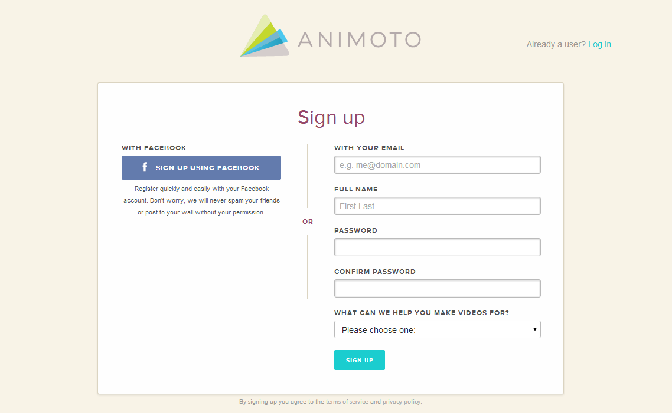

- Complete the registration process. Be sure to use your educator email and click on the dropdown box that says you will be using the videos for education.
- Once you have an account, scroll to the bottom of the home page and click on the link that says “Education”.
- Once you are on that page, click where it says “Learn More” after where it says “Are you a teacher?”
- Click “Apply now”.
- Fill out the Animoto for Education Application.

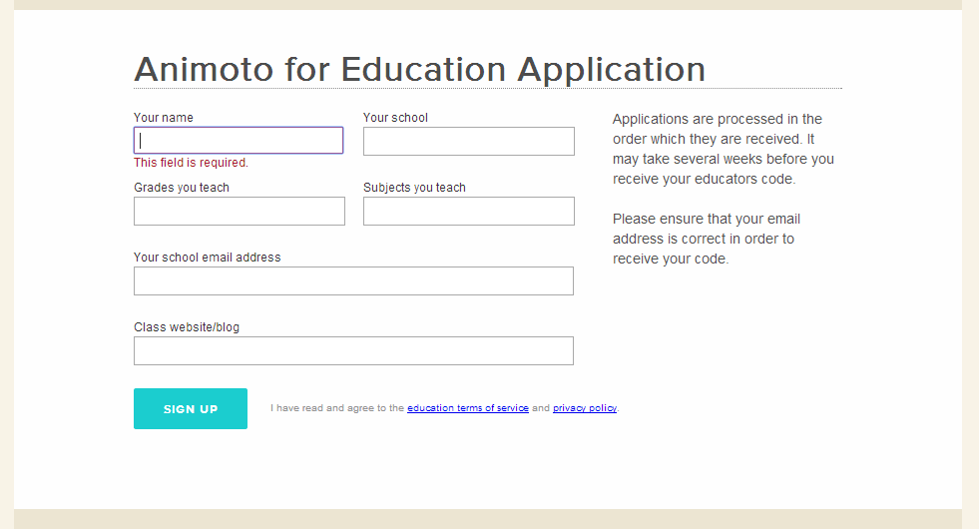

- After your application is submitted a promo code will be displayed. Copy or write down this code.
- To get your educator account. Click on your name at the top right of the page and select “Account”.
- Where it says “Redeem promo code”, enter the promo code that you were just given and click “submit code”.
- When you submit the code, it will say “You are currently an Animoto for Education customer”.

Animoto Training

Can also be accessed by using this link http://help.animoto.com/entries/415073-How-do-I-get-started-

How do I get started?

Step 1 - Sign Up
To get started on Animoto, you'll need to register a free Animoto account. Click "Sign Up" to begin, or click "Sign In" to access your account.

Step 2 - Create Video
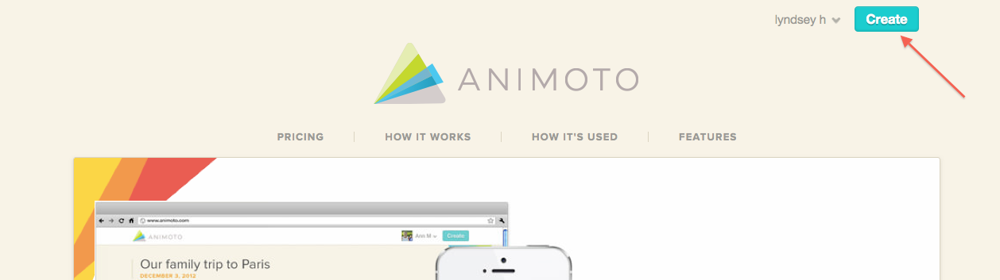
Click "Create" in the upper right to begin.

Step 3 - Choose a Style
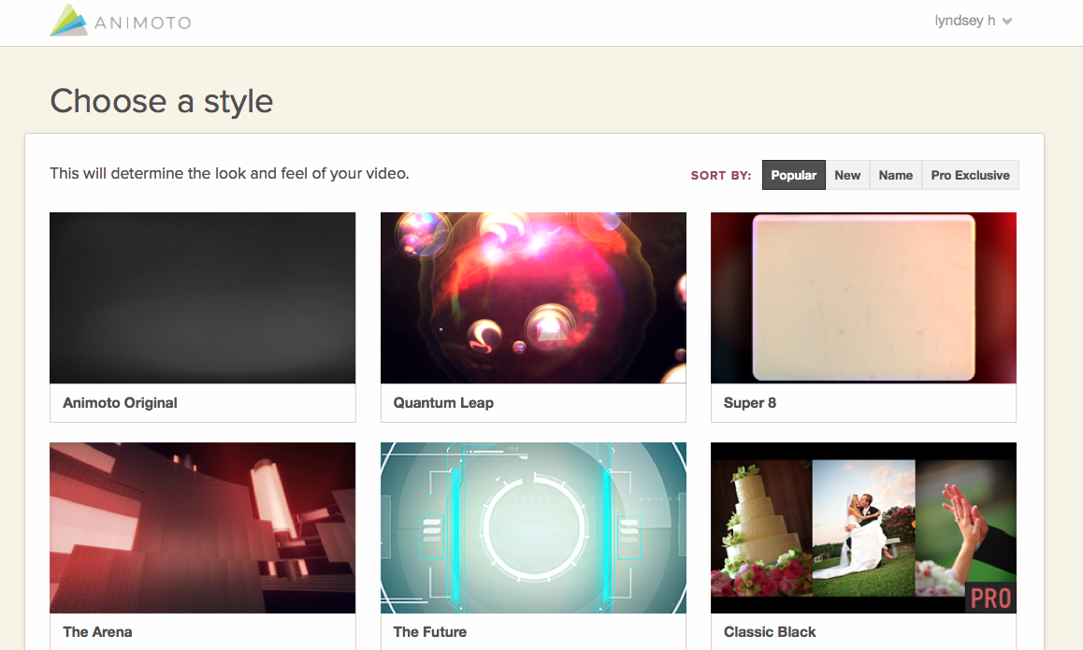
The style affects the look and feel of your video. Click on any of the styles to see a preview of what a video would look like in that style.

Step 4 - Add Images & Music

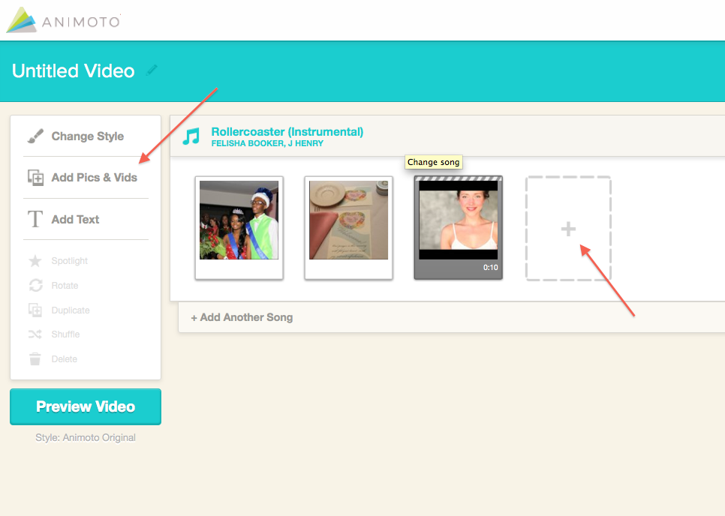
Animoto will then walk you through the steps required to create a video, including uploading photos and video clips and choosing a song. Don't forget Advanced Settings in the top-right corner to add those extra great features that make your video pop.

Step 5 - Preview, Produce & Share!
When you're all done, click the blue "Preview" button, Preview or skip and Produce and relax. We'll email when your video is ready to watch and share!
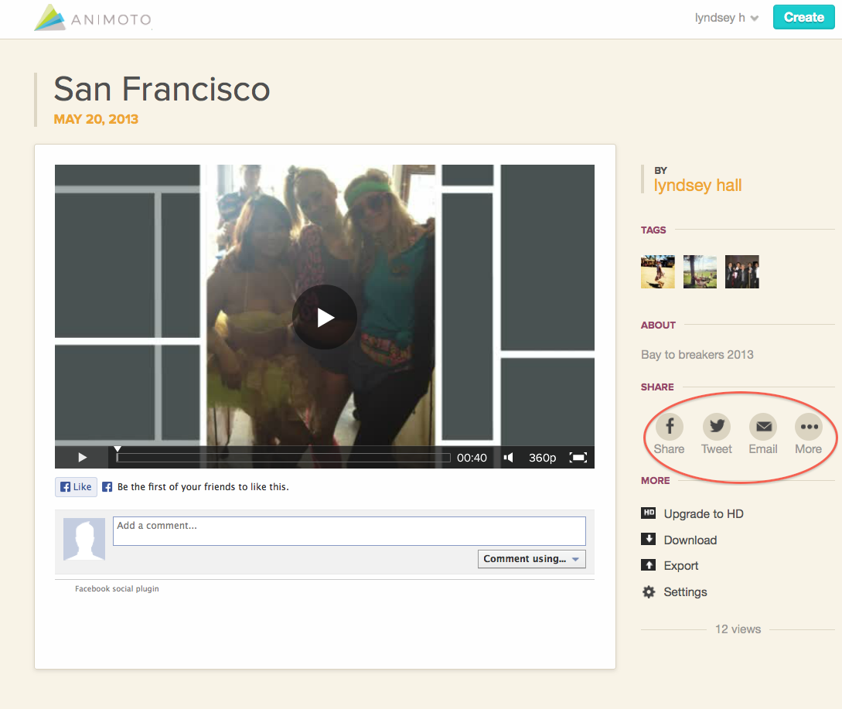

Important Tips for Using Your Own Images and Video Clips in Animoto
- Supported image formats are JPG, GIF, PNG and TIFF.
- Currently Animoto does support animated GIFs or transparency.
- The maximum supported file size is 20Mb.
- Images can be uploaded from your computer or imported from Facebook, Flickr, SmugMug, Photobucket, Picasa or Instagram.
- For the best quality videos, it is recommend that images are sized to 1024x768 pixels or greater.
- Lower resolution images may look blurry if you upgrade your video to a higher resolution or view it in full-screen mode.
- 4:3 or 3:4 landscape and portrait aspect ratios produce the best results.
- Images in other aspect ratios are perfectly usable, however they may appear zoomed out or cropped in the final video.
- If you're wondering what DPI you should use, keep in mind that DPI is only for print, so 1280x720 pixels is enough information. (For instance, a 1024x768 pixel image at 300 dpi will print at roughly 3.5x2.5 inches, and at 100dpi, it will print at roughly 10x7.5 inches. However, the screen ignores all that and just cares about the pixel resolution, the 1024x768 number.)
- The following file extension for video are currently supported by Animoto: MP4, AVI, MOV, QT, 3GP, M4V, MPG, MPEG, MP4V, H264, WMV, MPG4, MOVIE, FLV, DV, MKV, MJPEG, OGV, MTS, MVI.

These materials (plus additional videos) can be found at: http://help.animoto.com/forums
“Animoto Help” Fri. 2 May.2014. http://help.animoto.com/forums

B.4 - Take - Away Card
Card should be printed on cardstock. Educators will record their Username and password during the presentation.

